Where are all the Uber drivers? Not in these government statistics

By Louis Hyman

JUL 27, 2018 | 12:55 PM

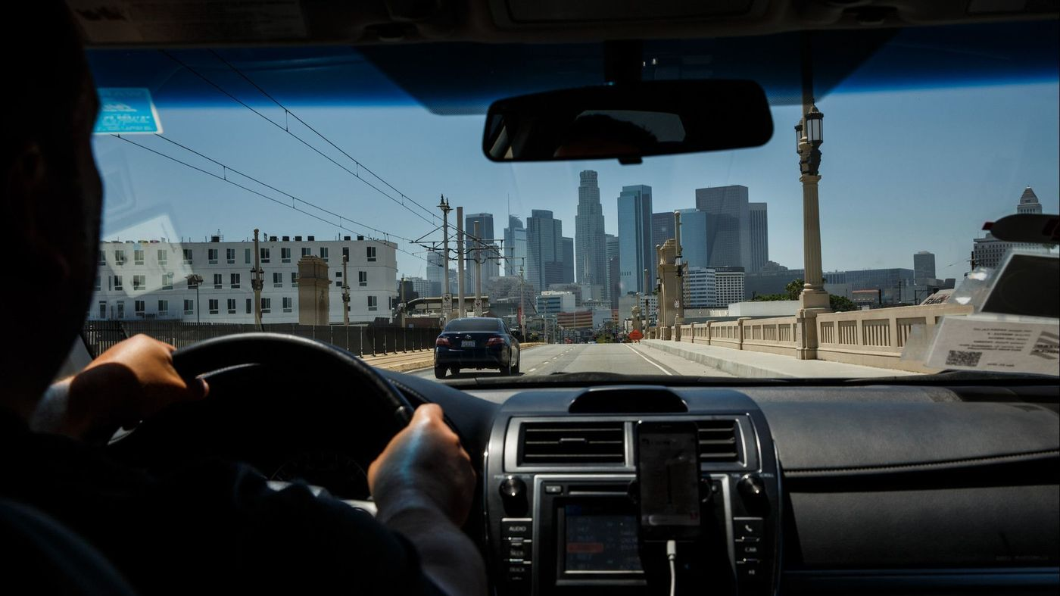

The view the downtown skyline seen from inside an Uber ride in Los Angeles, on June 21, 2017. (Los Angeles Times)

Earlier this summer, the federal Bureau of Labor Statistics released the results of its first Contingent Worker Survey since 2005. With all the talk these days about the gig economy, observers thought the survey would reveal a sharp rise. Recent estimates done by worker groups and corporate think tanks — like those by Upwork and the Freelancers Union, or by McKinsey & Co. — suggested the number could be 30% to 40% of the workforce.

So pundits, myself included, were shocked that the bureau reported that the share of contingent workers in the labor market actually fell from 10.7% to 10.1%. What gives? In 2005, Uber didn’t exist, and now it claims to have 3 million drivers. Where are all the Uber drivers, let alone the Task Rabbits and the Upworkers?

The answer lies in how we define our terms. There is no consensus on who qualifies as a contingent worker, and that’s one reason the bureau is still missing the big picture on how increasingly insecure American workers are in their jobs.

Full-time employees everywhere know that being replaced by a temp or a contractor is not just a possibility, but part of their HR department’s plan.

The phrase “contingent worker” was coined in 1985 by Audrey Freedman. She’d been a supervising economist at the Bureau of Labor Statistics and had seen as clearly as anyone how the postwar world of secure, steady jobs was disappearing. The term then caught on among the academic set, who also were observing this fundamental change.

The trick to measuring the impact of this shift was clearly defining “contingent work.”

Defining the contingent workforce negatively — that is, *not* normal 9-to-5 weekly paycheck jobs — wouldn’t do. Good definitions are positive, but that was harder.

Contingent work, as Freedman used it, meant any kind of “conditional and transitory employment.” Under her definition, a case could be made for including part-timers, temps, freelancers, small-business owners, consultants, migrant farm workers — and any number of other kinds of work that did not fit into the postwar corporate model. That was too broad for the bureau, however. Into the late 1980s, Bureau of Labor Statistics economists like Anne Polivka and Thomas Nardone wrestled with how to define the term, lamenting that “the lack of an established definition” made measurement impossible.

Finally, the bureau advanced a definition based on the expectation of job security: If you didn’t have a future in your current job, you were a contingent worker.

Not until 1995 did the bureau conduct the first serious survey of contingent workers in the United States as part of its Current Population Survey, which examines tens of thousands of households.

The bureau asked individuals how long a job would last. The person’s job was categorized as contingent if “the person was working only until the completion of a specific project, temporarily replacing another worker, being hired for a fixed period, filling a seasonal job … or if other business conditions dictated that the job was short term.” Equally important, if the worker seemed to choose short-term work, they were not really “contingent.” (This is how a later bureau study could contain the paradoxical phrase: “only 24% of temps were contingent.”)

The headline numbers in 1995 were low — between 3 million and 6 million Americans, or about 1% of the workforce.

Contingent worker? What contingent worker?

But that same year, using the same data, if you included all independent contractors (8.3 million), on-call workers (2.0 million) and temps (1.8 million), you could also say the contingent workforce was 12.1 million, or 10% of the workforce.

The fundamental error, to my thinking, was suggesting that individual choice was driving this shift in employment. If the only jobs available were short-term, then of course people “chose” to take the only work to be found.

By focusing on individuals, the BLS also missed the big story: the change in the corporation.

Seen from the corporate angle, contingent workers weren’t then (nor are they now) temporary replacements. They were, and are, a permanent strategy for managing a company’s labor costs. The consulting company Deloitte has calculated that paying people is 50% to 60% of expenses at a typical Fortune 500 company. That is a big, fat target for cost-cutting.

For managers pushed to downsize, shifting work to a contractor or temp or freelancer (and showing the cost reduction in benefits) was an easy move. Rather than hire employees, companies began leasing workers from staffing agencies like Allegis and Adecco, or the more recognizable ManpowerGroup or Kelly Services. Further, these staffing agencies didn’t just “lease” out administrative or manual labor, but increasingly technology specialists, professionals and creative workers. The federal labor data captured little of that.

Bureau economists seemed to go out of their way to ignore the fact that contingent jobs weren’t a convenient personal choice, but an unwelcome necessity. The effect of this major shift has been felt throughout corporate America. Full-time employees everywhere know that being replaced by a temp or a contractor is not just a possibility, but part of their human resources department’s plan.

The definition of contingent worker remains unsettled and ineffectual today. The Bureau of Labor Statistics, in an effort to make the categories from 1995 onward comparable, has not altered its survey definitions. In the meantime, for many millions of Americans, work has become even less secure.

Reconciling government statistics with our lived experiences (and other surveys) will require new approaches. The bureau certainly will need to update and expand its definitions of contingent work. At the same time, we need to survey corporations to analyze how they are now using temps and contractors alongside traditional employees. If we want to understand why Americans are winding up in contingent work — and what to do about that — we need to first look at how extensively corporations are outsourcing their labor.

*Louis Hyman is a history professor at Cornell University. This piece is adapted from his forthcoming book, “*[*TEMP*](https://www.amazon.com/Temp-American-Business-Became-Temporary/dp/0735224072)*: How American Work, American Business, and the American Dream Became Temporary,” from Viking, on sale August 21st.*